**Servlet**

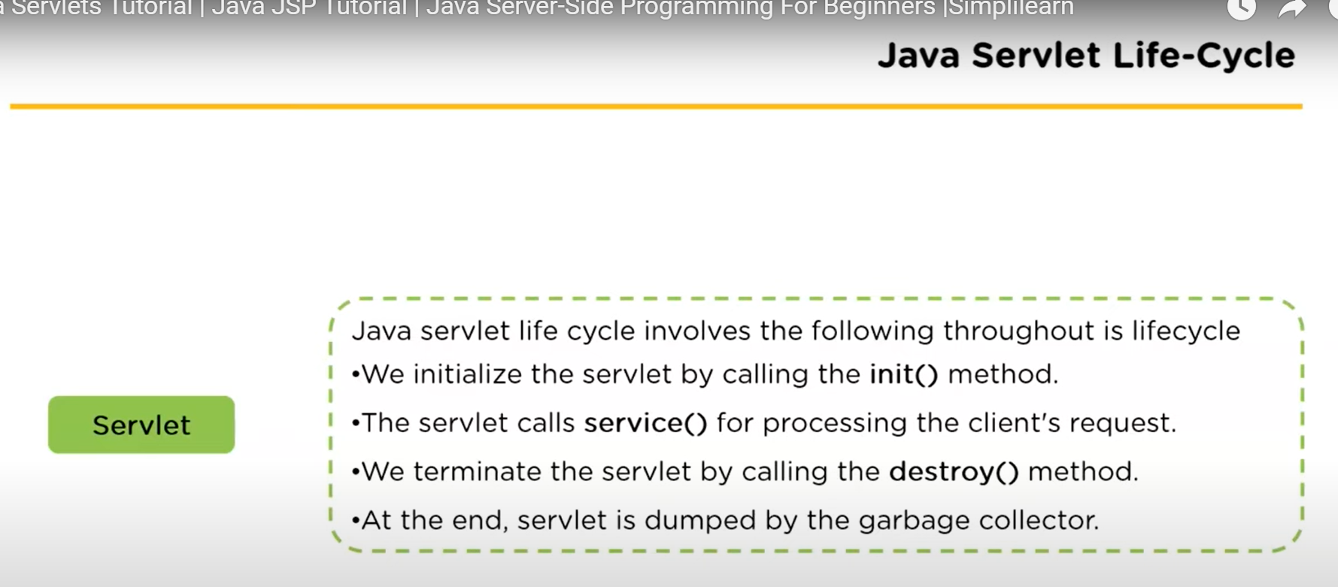

1. **Init():** The init() method is called only once in the entire process. It is called only when the servlet is created. The servlet is normally created when a user first invokes a url corresponding to the servlet but we can also specify the servlet is loaded when the server first started. When a user invokes a servlet a single instance of each servlet gets created with each user request resulting in a new thread that is handed over to the doGet or doPost as appropriate.  
   It is used for the one-time initializations.  
   The init() method creates or loads some data that will be used throughout the lifecycle of a servlet.  
   Syntax:   
   *public void init() throws ServletException{  
   //Statements;  
   }*
2. Service(): Followed by the init() method, we have the service method. The service() method is the main method defined to perform the actual task required.   
   The servlet container that is the web server calls the service method to handle request from the client or the browser and to write the formatted response back to the client. Each time the server receives a request from the servlet, the server spawns a new thread and calls service. The service method checks the http service type and accordingly performs the crud operations which are the get, post, put, delete etc and calls doGet(), doPost(), doPut(), doDelete() etc methods as appropriate.  
   The service method is called by the container and and calls doGet(), doPost() etc method. So you’ve nothing to do with service method but you overwrite either with doGet(), doPost and other types depending on what type of request you receive from the client.

Syntax:  
*public void service(ServletRequest Rq, ServletResponse Rs) throws ServletException, IOException{  
//Statements;  
}*

CRUD Operaiton Methods in Service():-

doGet(): A GET request results from a normal request for a URL or from an HTML form that has no METHOD specified and it should be handled by doGet() method.

So, doGet basically gets the information what you’re looking for.  
Syntax:  
*public void doGet(ServletRequet rq, ServletResponse Rs) throws ServletException, IOExceptino{  
//Statements;  
}*

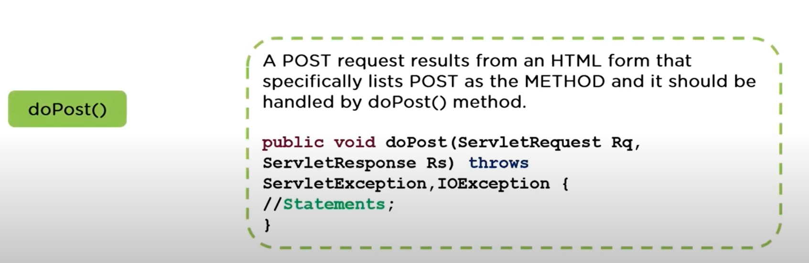

So, doPost method usually post the information or provides you with the response from the server and followed by that we’ve the doPut which is usually used to update the data which is present on your server and finally delete which is used to delete an existing data on your server.

1. 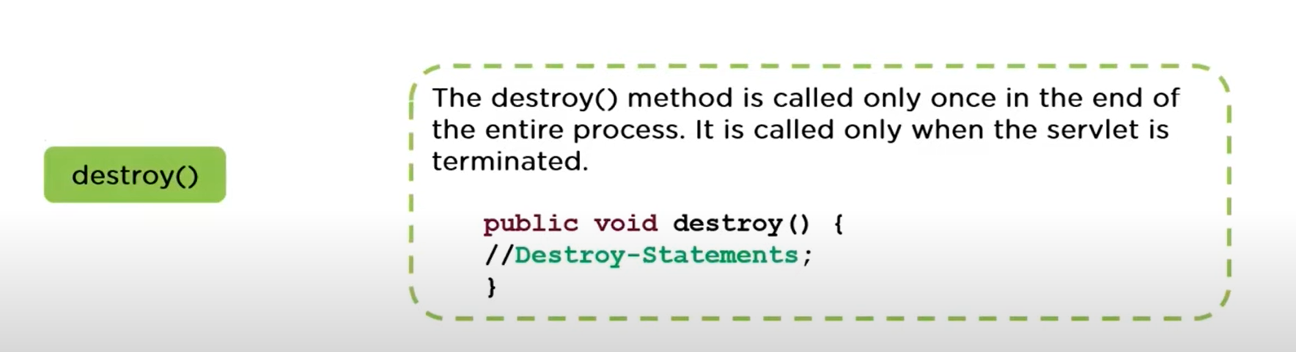

This method gives your servlet a chance to close database connections, halt background threads, right cookie list or hit accounts to the disk and performs other such clean-up activities.

**SERVLET Architecture**

To write servlet we need to implement servlet interface.

Servlet interface can be implemented directly or indirectly by extending generic servlet or http servlet class.

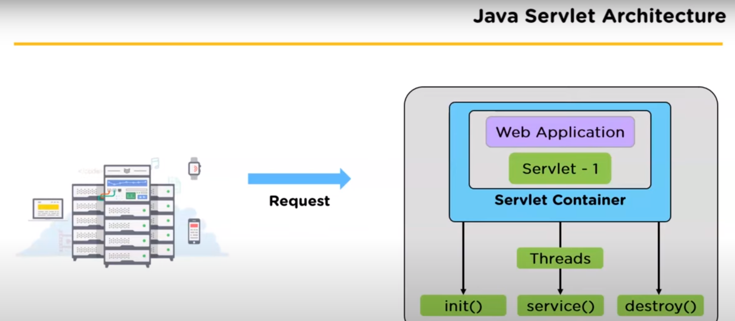

Request Handling Methods():-

There are mainly three methods defined in servlet interface which are init(), service() & destroy(). And inside service() we’ve doGet(), doPost(), doPut() and doDelete().

The first time a servlet is invoked the init() method Is called. It is called only once during the life cycle of a servlet. So we can put all your initialization code here.